Target Distribution System Logic

System Logic Overview – “How the System Thinks”
The system processes four primary inputs to generate accurate and validated sales targets at the customer, site, and route levels:
- Historical Sales Data – User uploads only the most recent month; previous months are stored in the database.
- Target Sheet – SKU-level targets per channel.
- Routes File – Customer and route mapping (start sheet).
- Price List (PPL) – SKU prices per channel.

Step 1 — Target Allocation at the Super Channel Level
- The system iterates through each Super Channel.
- The target assigned to a Super Channel is proportionally distributed to the Channels under it.
- Allocation is based on each Channel’s historical share within the Super Channel.
- The result is a target value and unit count for each Channel.

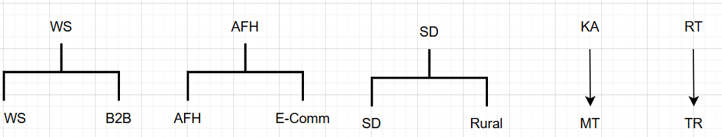

Step 2 — SKU and Customer Identification
- SKU Reference: Extract all unique SKUs from the Target Sheet (primary SKU reference list).
- Customer Reference: Extract all customers from the Routes File.
- Customer Linking: Match customers to Historical Sales Data using customer_id.

Step 3 — Baseline Sales Calculations
- SKU Sales: Calculate total sales for each SKU in each Channel.
- Channel Sales: Calculate total sales of all customers per Channel.
- Price Assignment: Map each SKU in each Channel to its price from the PPL file.

Step 4 — Contribution Calculation
- Calculate Customer-SKU Sales = sales of each customer for each SKU in each Channel.
- Contribution % =
$$Customer SKU Sales ÷ Total SKU Sales in Channel$$
- Missing Data Handling:
  - No SKU Sales Data:
Use the Sub-Brand the SKU belongs to and calculate contribution percentage at Sub-Brand level (Currently being distributed by the customer’s contribution to the channel)
  - No SKU & No Sub-Brand Data:
Flag for user input — user selects a similar SKU to serve as a proxy.
  - New Customer:
If not all months are zero, use available month(s) to calculate contribution.

Below is a chart to further illustrate this logic:
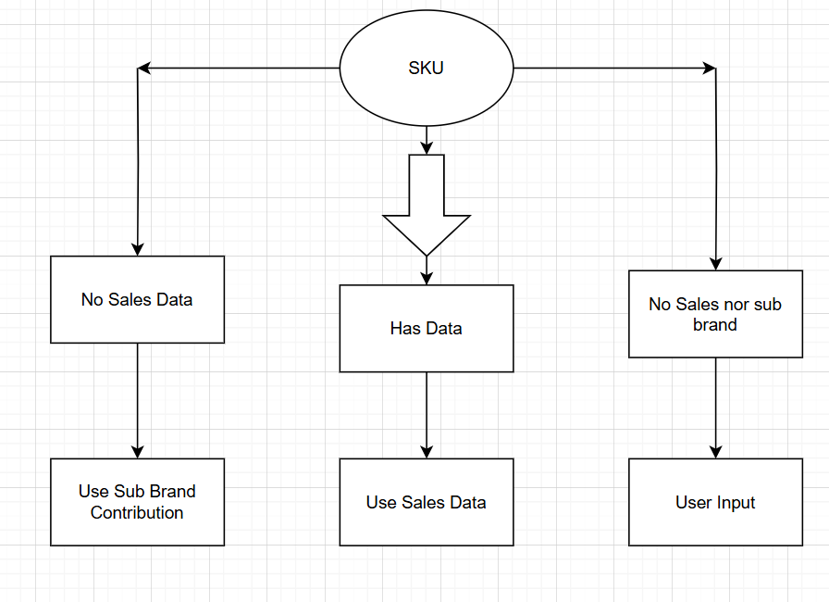

Step 5 — Normalization
- All contribution percentages are normalized so they sum to 100% per SKU per Channel.

Step 6 — Target Assignment
- Customer-SKU Target Units =
SKU Target Units x Customer Contribution %
- Customer-SKU Target Value =
Target Units × SKU Price

Channel | Price from PPL
WS | WS
SD | WS
TR | RT
Rural | RT
AFH | RT
MT | KA
B2B | B2B
E-comm | KA

Step 7 — Validation Checks
- Channel-Level Check:
Sum of all customers’ target units and values per Channel equals the Channel’s target.
- Super Channel-Level Check:
Sum of all Channels’ totals equal the Super Channel target.

Customer | Channel | Sales (Customer) | Sales (Channel total) | Difference
C001 | Online | 1000 | 3000 | ✅ 0
C002 | Online | 2000 | 3000 | ✅ 0
Sum for Channel | Online | 3000 | 3000 | ✅ 0

8. Site/Route-Level Mapping
Once customer-level targets are finalized, the system maps each customer to their associated site(s) or route(s) based on operational mapping data. The allocated targets are then re-associated at this site/route level, enabling operational teams to work with location-specific target figures.

Step 9 — Final Integrity Check
- Ensure every SKU from the Target Sheet appears in the results.
- Ensure every Customer from the Routes File appears in the results.

This flow ensures that all targets are distributed based on actual sales performance while maintaining accuracy, traceability, and alignment with operational structures.

Comparison between final system results and previously calculated results:

Whole flow summary

